Promoting an Open Culture of Promoting Positive Mental Health

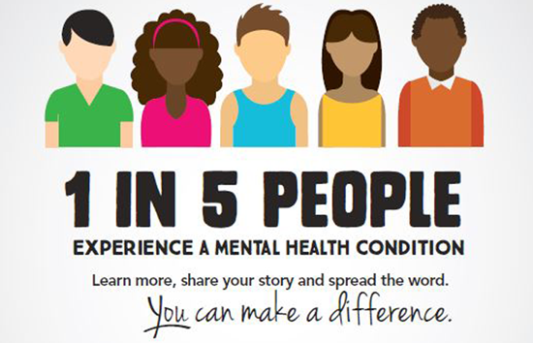

As of 2016, nearly 1 in 5 U.S. adults lives with a mental illness (44.7 million). [1](<https://www.nimh.nih.gov/health/statistics/mental-illness.shtml>) With such widespread incidence, there is a growing community and workplace focus on opening up the conversation about mental health, and tackling negative attitudes that can prevent people from accessing help.

### The Goal:

Help people understand the impact of mental illnesses, and provide an open discourse for promotion of positive mental health – especially for those seeking help.

**Raising Awareness**

**Breaking down stigmas**

So, How can we remove the stigma around mental health?

**Providing an open dialogue**

Provide a positive discourse for those that want to overcome their condition

### My Personal Commitment:

I am committed to promoting mental health awareness, establishing an open dialogue that is focused on understanding, dispelling mental health myths, and raising awareness of the skills needed to manage personal emotional health.

I practice my commitment to an open mental health culture by providing a listening ear and offering guidance on finding support.

Promoting positive mental health in everyday life is beneficial for everyone.

What is positive mental health?

How can you promote positive mental health in daily life?

Why is promoting positive mental health important?

Like any other chronic condition, mental health conditions can get worse if left untreated. This often results in crisis events like inability to work, hospitalization, homelessness or incarceration.

The good news is, mental health conditions are not only common, they are treatable - especially when they are treated early. There are a variety of treatment options ranging from talk therapy to medication to peer support. The earlier we treat mental health conditions, the easier it is for people to recover and the less it costs.

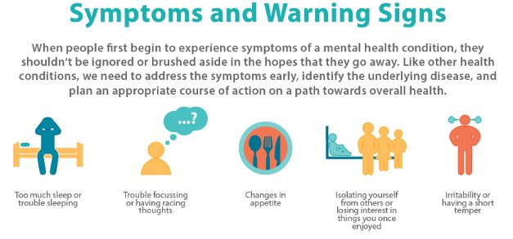

*Confidentiality:*

I will treat all matters sensitively and privately – seeking consent before sharing confidential/personal information with professionals. Personal/confidential information will not be shared with anyone that is not a designated mental health professional intended to provide help.

*Disclaimer:*

Mental health advocates are not mental health experts. Advocacy is a means to providing awareness, understanding, and resources. Guidance, medication, and support should be provided by certified professionals who are experts in providing care.

*Know Your Rights:*

Legislation exists to protect people with mental illness from discriminatory practices and provide structured practices for safeguarding health information and your right to seek care:

* Americans with Disabilities Act of 1990

* Mental Health Parity Act of 1996

* Medicare Improvements for Patients and Providers Act

* Paul Wellstone and Pete Domenici Mental Health Parity and Addiction Equity Act of 2008

* Affordable Care Act of 2010

*Safety:*

Advocates have an obligation to protect the physical safety of themselves, and others – contact law enforcement immediately if imminent physical harm is suspected.

*Sources:*

Your Rights Under HIPAA, U.S. Department of Health and Human Services. http://www.hhs.gov/hipaa/for-individuals/guidance-materials-for-consumers/index.html

HIPAA Privacy Rule and Sharing Information Related to Mental Health, U.S. Department of Health and Human Services http://www.hhs.gov/hipaa/for-professionals/special-topics/mental-health/index.html

Legal and Ethical FAW, American School Counselor Association. https://www.schoolcounselor.org/school-counselors-members/legal-ethical/legal-ethical-faq

Confidentiality Laws Tip Sheet, American Academy of Pediatrics. https://www.aap.org/en-us/advocacy-and-policy/aap-health-initiatives/healthy-foster-care-america/Doc...

Your Health Information and Privacy Rights, U.S. Department of Health and Human Services Office for Civil Rights. http://www.hhs.gov/sites/default/files/ocr/privacy/hipaa/understanding/consumers/consumer_rights.pdf